SQL TASK WEEK II

Student Management System (SMS)


S/N | Name
1 | Bashir Aminat
2 | Lateefah Abdul-Rahman
3 | Hawwa Atta
4 | Jimoh Abdul-Rahman
5 | Damilare
6 | Oluwajuwonlo
7 | Toyyib A. Olalekan

Overview
The primary objective of this project is to design and create a relational database for a Student Management System (SMS) using SQL. The database should efficiently store and manage data on students, courses, instructors, and enrollments, enabling users to perform key administrative functions such as adding students, assigning courses, and generating dynamic reports through SQL queries.

DATA SOURCE
Datasets | Student Management System Dataset.xlsx
tools used | Microsoft SQL Server  SQL Server Management Studio  MySQL  Excel  drawSQL  dbdiagram.io  MySQL Workbench

Tables to be Created
- Students (StudentID, Name, Gender, DOB, DepartmentID)
CREATE DATABASE StudentManagementSystems – Create SMS Database

CREATE TABLE Students (
StudentID INT PRIMARY KEY IDENTITY(1,1),
Name VARCHAR(100) NOT NULL,
Gender CHAR(1) CHECK (Gender IN ('M', 'F')),
DOB DATE,
DepartmentID INT,
FOREIGN KEY (DepartmentID) REFERENCES Departments(DepartmentID)
);
- Departments (DepartmentID, DepartmentName)
CREATE TABLE Departments (
DepartmentID INT PRIMARY KEY IDENTITY(1,1),
DepartmentName VARCHAR(100) NOT NULL
);
- Courses (CourseID, CourseName, DepartmentID)
CREATE TABLE Courses (
CourseID INT PRIMARY KEY IDENTITY(1,1),
CourseName VARCHAR(100) NOT NULL,
DepartmentID INT,
FOREIGN KEY (DepartmentID) REFERENCES Departments(DepartmentID)
);
- Enrollments (EnrollmentID, StudentID, CourseID, EnrollmentDate)
CREATE TABLE Enrollments (
EnrollmentID INT PRIMARY KEY IDENTITY(1,1),
StudentID INT,
CourseID INT,
EnrollmentDate DATE DEFAULT GETDATE(),
FOREIGN KEY (StudentID) REFERENCES Students(StudentID),
FOREIGN KEY (CourseID) REFERENCES Courses(CourseID)
);

- Instructors (InstructorID InstructorName, Gender, DepartmentID, CourseID, HireDate, Email)
CREATE TABLE Instructors (
InstructorID INT PRIMARY KEY IDENTITY(1,1),
InstructorName VARCHAR(100) NOT NULL,
Gender CHAR(1) CHECK (Gender IN ('M', 'F')),
DepartmentID INT,
HireDate DATE,
Email VARCHAR(100) UNIQUE,
CourseID INT,
FOREIGN KEY (DepartmentID) REFERENCES Departments(DepartmentID)
FOREIGN KEY (CourseID) REFERENCES Courses(CourseID)
);

Insightful Reporting Questions (SQL-Based)

Student & Enrollment Reports
- How many students are currently enrolled in each course?
SELECT c.CourseName,c.CourseID, COUNT(e.StudentID) AS EnrolledStudents
FROM Courses c
LEFT JOIN Enrollments e ON c.CourseID = e.CourseID
GROUP BY c.CourseName, c.CourseID
ORDER BY EnrolledStudents DESC;
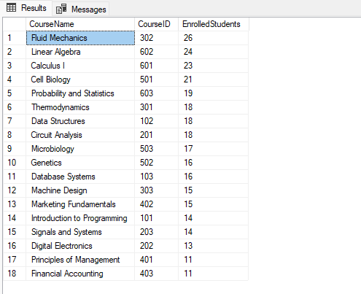
- Which students are enrolled in multiple courses, and which courses are they taking?
SELECT s.Name,s.StudentID, COUNT(e.CourseID) AS CourseCount
FROM Students s
JOIN Enrollments e ON s.StudentID = e.StudentID
GROUP BY s.Name, s.StudentID
HAVING COUNT(e.CourseID) > 1;
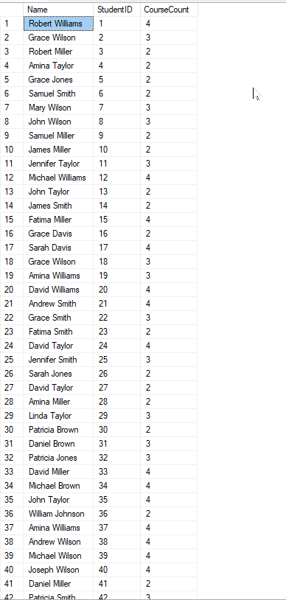
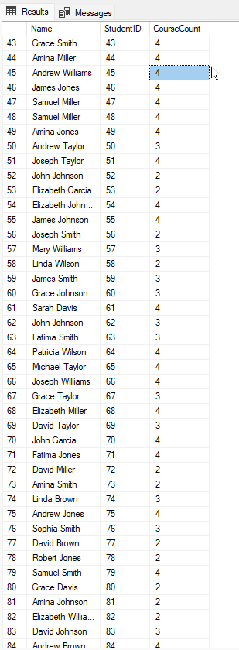
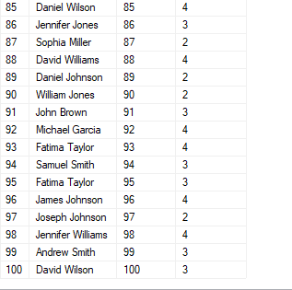
SELECT s.Name, s.StudentID,c.CourseName
FROM Students s
JOIN Enrollments e ON s.StudentID = e.StudentID
JOIN Courses c ON e.CourseID = c.CourseID
WHERE s.StudentID IN (
SELECT StudentID
FROM Enrollments
GROUP BY StudentID
HAVING COUNT(CourseID) > 1
)
ORDER BY s.Name;
- What is the total number of students per department across all courses?
SELECT d.DepartmentName,
COUNT(DISTINCT e.StudentId) AS No_Of_Students
FROM departments d
LEFT JOIN courses c ON d.DepartmentID = c.DepartmentId
LEFT JOIN enrollments e ON c.CourseId = e.CourseId
GROUP BY d.DepartmentName
ORDER BY No_Of_Students DESC;

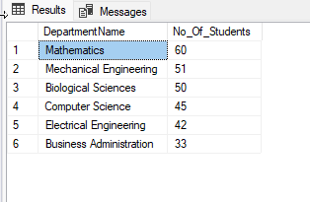

Course & Instructor Analysis
- Which courses have the highest number of enrollments?
SELECT TOP 5 WITH TIES c.CourseName,c.CourseID, COUNT(e.StudentID) AS EnrollmentCount
FROM Courses c
JOIN Enrollments e ON c.CourseID = e.CourseID
GROUP BY c.CourseName,c.CourseID
ORDER BY EnrollmentCount DESC;
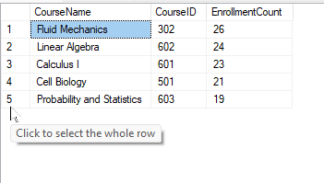
- Which department has the least number of students?
SELECT TOP 1 WITH TIES d.DepartmentName,d.DepartmentID, COUNT(s.StudentID) AS StudentCount
FROM Departments d
LEFT JOIN Students s ON d.DepartmentID = s.DepartmentID
GROUP BY d.DepartmentName, d.DepartmentID
ORDER BY StudentCount ASC;
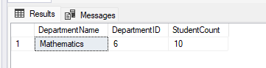

Data Integrity & Operational Insights
- Are there any students not enrolled in any course?
SELECT s.Name, s.StudentID
FROM Students s
LEFT JOIN Enrollments e ON s.StudentID = e.StudentID
WHERE e.EnrollmentID IS NULL;
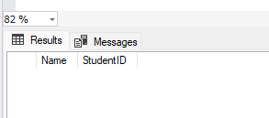
- How many courses does each student take on average?
SELECT AVG(No_Of_Courses) AS Avg_Courses
FROM (SELECT StudentId,
COUNT(CourseId) AS No_Of_Courses
FROM enrollments
GROUP BY StudentId
) AS StudentCount;
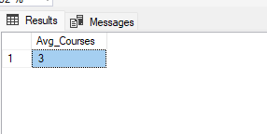

- What is the gender distribution of students across courses and instructors?
SELECT c.CourseName, s.Gender, COUNT(s.StudentID) AS StudentCount
FROM Courses c
JOIN Enrollments e ON c.CourseID = e.CourseID
JOIN Students s ON e.StudentID = s.StudentID
GROUP BY c.CourseName, s.Gender
ORDER BY c.CourseName;
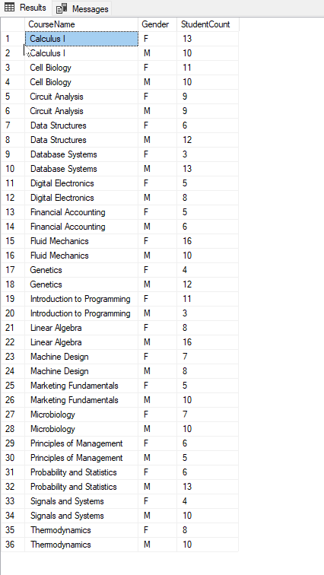

SELECT Gender, COUNT(InstructorID) AS InstructorCount
FROM Instructors
GROUP BY Gender;

OR
SELECT
COUNT(CASE WHEN I.Gender = 'M' THEN 1 END) AS Male_Instructors,
COUNT(CASE WHEN I.Gender = 'F' THEN 1 END) AS Female_Instructors,
COUNT(I.InstructorID) AS Total_Instructors
FROM Instructors I;
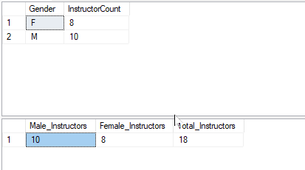
- Which course has the highest number of male or female students enrolled?
SELECT c.CourseId,
c.CourseName,
i.InstructorName,
i.Gender AS Instructor_Gender,
COUNT(CASE WHEN s.Gender = 'M' THEN 1 END) AS Male_students,
COUNT(s.StudentId) AS Total_Students
FROM courses c
LEFT JOIN instructors i ON c.CourseId = i.CourseId
LEFT JOIN enrollments e ON c.CourseId = e.CourseId
LEFT JOIN students s on e.StudentId = s.StudentId
GROUP BY c.CourseId, c.CourseName, i.InstructorName, i.Gender
ORDER BY Male_students DESC

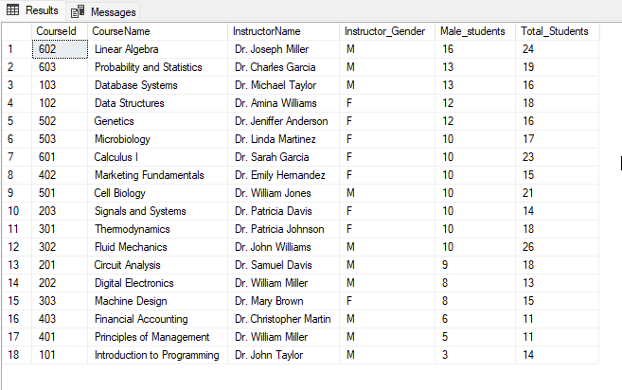

Entity Relationship Diagram (ERD) showing all tables and their relationships

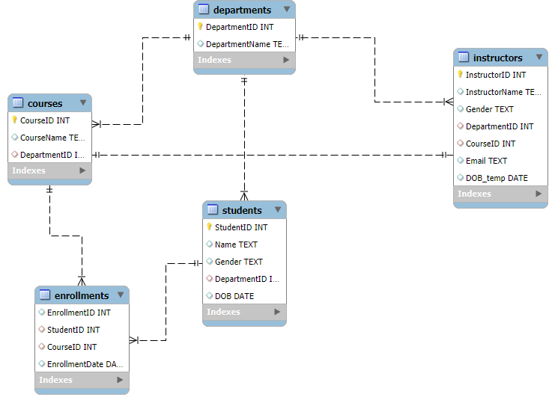

Overview of the relational database schema designed for the Student Management System (SMS).

Table Structures

1. Departments
Stores information about the various academic departments.
Column Name | Data Type | Constraints | Description
DepartmentID | INT | PK, IDENTITY(1,1) | Unique identifier for the department.
DepartmentName | VARCHAR(100) | NOT NULL | Name of the department.

2. Students
Contains records of all registered students.
Column Name | Data Type | Constraints | Description
StudentID | INT | PK, IDENTITY(1,1) | Unique identifier for the student.
Name | VARCHAR(100) | NOT NULL | Full name of the student.
Gender | CHAR(1) | CHECK ('M','F') | Gender of the student.
DOB | DATE | NULL | Date of birth.
DepartmentID | INT | FK | References Departments(DepartmentID).

3. Instructors
Details of faculty members.
Column Name | Data Type | Constraints | Description
InstructorID | INT | PK, IDENTITY(1,1) | Unique identifier for the instructor.
InstructorName | VARCHAR(100) | NOT NULL | Full name of the instructor.
Gender | CHAR(1) | CHECK ('M','F') | Gender of the instructor.
DepartmentID | INT | FK | References Departments(DepartmentID).
CourseID | INT | FK | References Courses(COurseID)
HireDate | DATE | NULL | Date the instructor was hired.
Email | VARCHAR(100) | UNIQUE | Contact email.

4. Courses
List of courses offered by departments.
Column Name | Data Type | Constraints | Description
CourseID | INT | PK, IDENTITY(1,1) | Unique identifier for the course.
CourseName | VARCHAR(100) | NOT NULL | Name of the course.
DepartmentID | INT | FK | References Departments(DepartmentID).

5. Enrollments
Records which students are taking which courses.
Column Name | Data Type | Constraints | Description
EnrollmentID | INT | PK, IDENTITY(1,1) | Unique identifier for the enrollment record.
StudentID | INT | FK | References Students(StudentID).
CourseID | INT | FK | References Courses(CourseID).
EnrollmentDate | DATE | DEFAULT GETDATE() | Date when the student enrolled.

Relationships
- One-to-Many:
  - A Department can have multiple Students, Instructors, and Courses.
  - A Student can have multiple Enrollments.
  - A Course can have multiple Enrollments.
- Many-to-Many:
  - Students and Courses have a many-to-many relationship, resolved through the Enrollments junction table.
- One-to-one
  - There is a one to one cardinality between the courses and instructors table

SQL query logic used
  - JOINs: Combine related tables (LEFT JOIN keeps rows even if no match).
  - GROUP BY: Aggregate data (counts, averages) per group.
  - COUNT / COUNT(DISTINCT): Count rows, optionally unique.
  - HAVING: Filter aggregated results.
  - Subqueries: It is used to filter or calculate based on other query results.
  - CASE WHEN: Conditional counts for gender

